**Step One: Convert your slides**

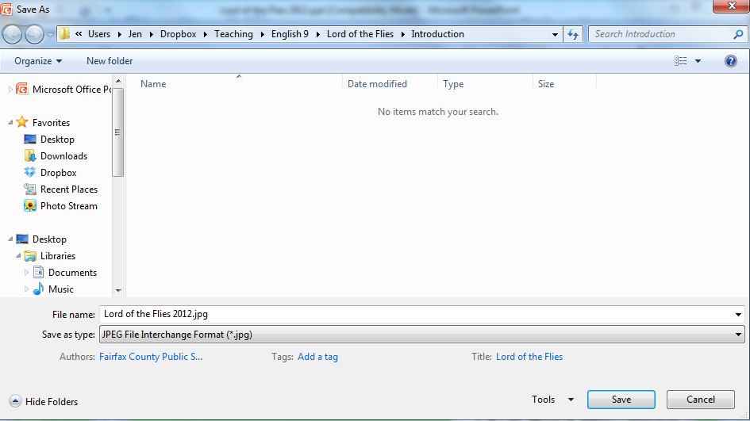Open the PowerPoint you want to convert to a video. Select “Save As…”

Be sure you’ve created a folder where you can find all your project files

Use the drop-down menu to select JPEG format

When you’ve selected the correct destination folder and format, select “Save.” When you see this pop up:

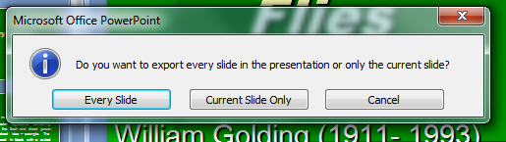

Select **“Every Slide”** and PowerPoint will automatically save all of your slides with numbers added to your file name (example: if you named your file “Grammar”, slides would be Grammar01, Grammar02, etc)

**Step Two: Photo Story 3**

Open Photo Story 3. (You can search for it by typing its name into the menu bar.)

Select to begin a new project:



On the next screen, select **“Import Pictures”** then find the files you saved in Step One.

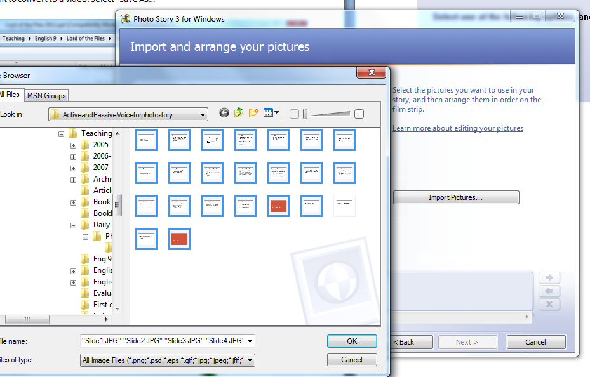If you are trying to import all of your slides, you can hold down “control” on the keyboard as you click on each slide, which will allow you to select more than one at a time (as indicated by the blue outline on selected slides).

Once your slides are imported, select “Next” on the bottom of the Photo Story window. **This step allows you to add additional text to your slides**. However, if you are importing a PowerPoint, you likely don’t need this feature unless you want to add additional image slides. **Select “Next” again.**

**Use the red circular button to record.** If you make a mistake, delete narration and then re-record. If you stop and then record again, it will simply add to what was previously recorded for that slide.

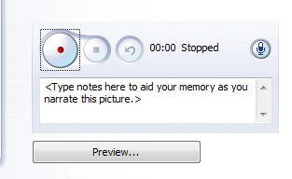

Record

Delete Recordings

Listen to Recordings

On each slide, you can also adjust the animation. Select “**Customize Motion**” which will bring up a new window:

Click and drag the box to adjust where the “camera” zooms

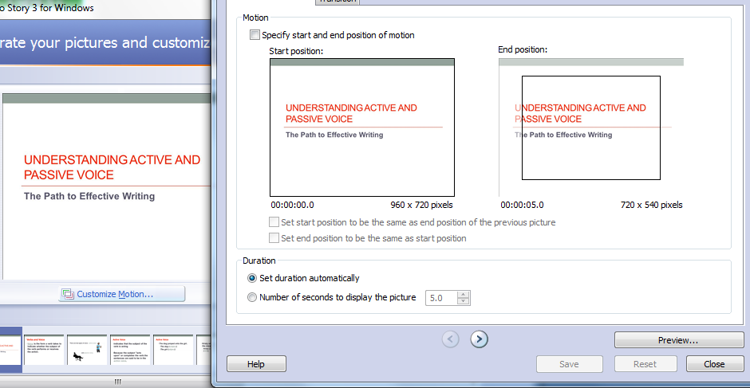

Photo Story automatically sets animation to zoom either in on or out from each slide. You can decide to remove this animation altogether by checking “set end position to be the same as the start position” and ensuring that the entire slide is in view.

**Be sure to use the “Preview” button to be sure each slide looks and sounds the way you want it to.**

**Saving**

Photo Story will save your video as a .wmv (windows movie) file, which is playable on most computers. Select “**Save for playback on my computer**” (the first option). When you click “next” this time, Photo Story will take a few minutes to convert all of your audio and visuals into a movie. Be sure to also save your Photo Story project file in case there is something you want to change when you watch the finished video.